Sprint Velocity Tracking Report
Project Name:Software Development Project Management Simulation: Campus Placement Portal
Project Duration: 12 Weeks
Methodology: Agile Scrum
Sprint Length: 2 Weeks
Purpose
Sprint Velocity is used to measure the amount of work completed by the team during each sprint. Velocity helps estimate future sprint capacity and evaluate team performance improvements over the project lifecycle.
Story Points are used as the unit of measurement.
Velocity Summary
Sprint | Duration | Planned Story Points | Completed Story Points | Velocity
Sprint 1 | Week 3–4 | 15 | 18 | 18
Sprint 2 | Week 5–6 | 20 | 20 | 20
Sprint 3 | Week 7–8 | 22 | 22 | 22
Sprint 4 | Week 9 | 25 | 25 | 25
Sprint 5 | Week 10 | 24 | 24 | 24
Sprint 6 | Week 11–12 | 26 | 26 | 26
Velocity Trend
Sprint | Velocity
Sprint 1 | 18
Sprint 2 | 20
Sprint 3 | 22
Sprint 4 | 25
Sprint 5 | 24
Sprint 6 | 26
Average Velocity
Calculation:
(18 + 20 + 22 + 25 + 24 + 26) ÷ 6 = 22.5 Story Points
Average Team Velocity: 22.5 Story Points per Sprint
Velocity Improvement Analysis
Comparison | Improvement
Sprint 1 → Sprint 2 | +2 SP
Sprint 2 → Sprint 3 | +2 SP
Sprint 3 → Sprint 4 | +3 SP
Sprint 4 → Sprint 5 | -1 SP
Sprint 5 → Sprint 6 | +2 SP
Overall Improvement
Initial Velocity (Sprint 1): 18 Story Points
Final Velocity (Sprint 6): 26 Story Points
Improvement: 26 - 18 = 8 Story Points
Percentage Improvement: (8 ÷ 18) × 100 = 44.4%
Total Velocity Improvement: 44.4%
Factors Contributing to Improvement
Sprint 1
Challenges:
- Project setup activities.
- Team familiarization with requirements.
- Initial environment configuration.
Impact: Lower velocity.
Sprint 2
Improvements:
- Better sprint planning.
- Clearer task ownership.
- Established communication process.
Impact: Velocity increased to 20.
Sprint 3
Improvements:
- Earlier QA involvement.
- Better backlog refinement.
- Improved requirement clarity.
Impact: Velocity increased to 22.
Sprint 4
Improvements:
- Increased familiarity with project architecture.
- Faster issue resolution.
- Reduced development bottlenecks.
Impact: Velocity increased to 25.
Sprint 5
Observations:
- Dashboard development required additional effort.
- Analytics features were more complex than expected.
Impact: Minor velocity reduction to 24.
Sprint 6
Improvements:
- Majority of development completed.
- Team focused on testing and release activities.
- Better sprint predictability.
Impact: Velocity increased to 26.
Velocity Performance Chart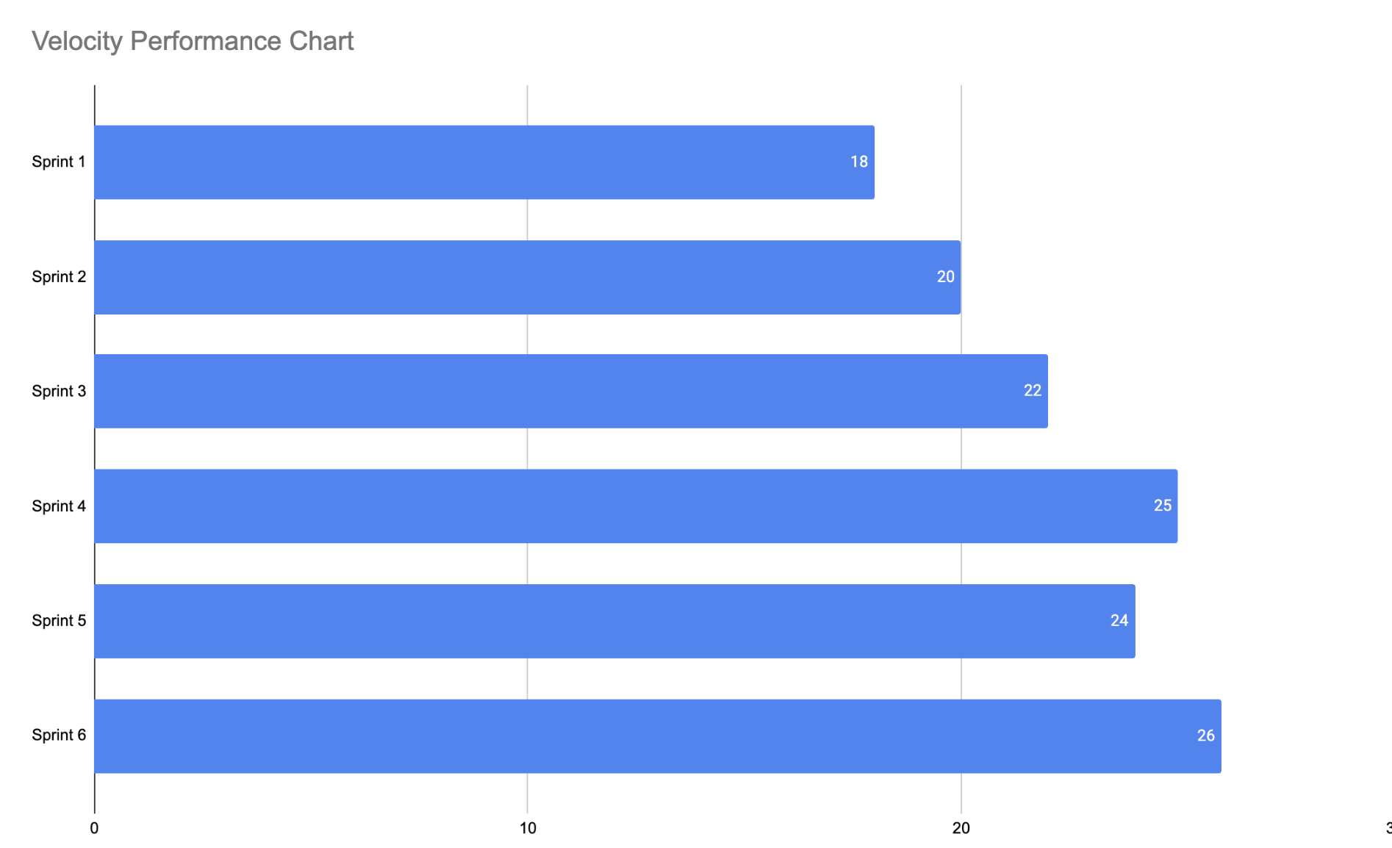Project Manager Observations
Positive Trends
- Continuous improvement in team productivity.
- Better collaboration between frontend and backend developers.
- More accurate sprint estimations over time.
- Reduced dependency-related delays.
Areas for Improvement
- Earlier identification of complex dashboard requirements.
- More detailed backlog refinement before sprint start.
KPI Summary
KPI | Target | Actual
Average Velocity | 20 SP | 22.5 SP
Final Velocity | 24+ SP | 26 SP
Sprint Completion Rate | 90%+ | 100%
Sprint Delivery | On Time | On Time
Conclusion
The team demonstrated steady performance improvement throughout the Campus Placement Portal project. Sprint velocity increased from 18 story points in Sprint 1 to 26 story points in Sprint 6, representing a 44.4% improvement in delivery capacity.
This improvement was achieved through structured retrospectives, clearer requirement definitions, better sprint planning, proactive risk management, and increased collaboration among team members. The velocity trend indicates a maturing Agile team capable of delivering project objectives within the planned timeline.

